

To check your current mailing address, go to MyOregonState and click on the ‘Resources’ tab in the Student Dashboard.

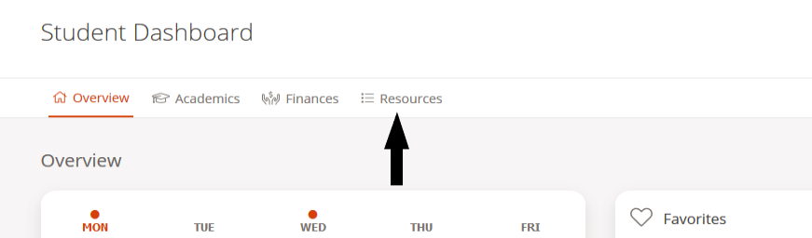

Scroll through the full list of resources or search for address. Click ‘View/Update Address and Phone.’

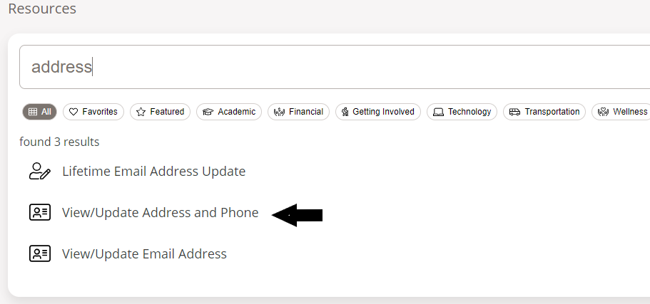

You will see your current mailing address. If it looks correct, no further action is needed. If it needs to be changed, click ‘Current’ beside the address.

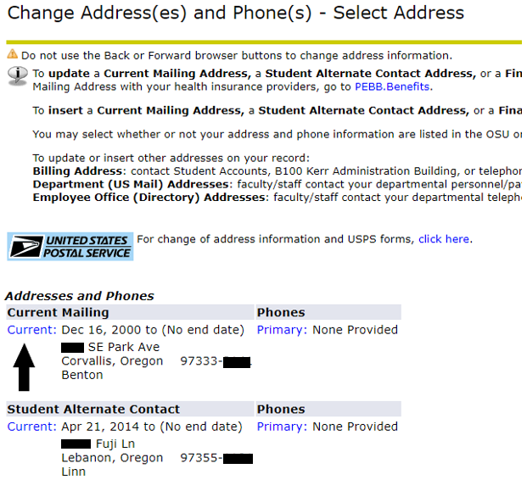

You can enter a different current mailing address for the present or for a future date. Enter the date from which the address will be valid. Update the address. Click Save.
